**Output Screen Shots**

**Project: - AWS Technical Essentials Project – Server Monitoring**

**Tasks:-**

1. Check and observe the CPU utilization graph for the EC2 instance

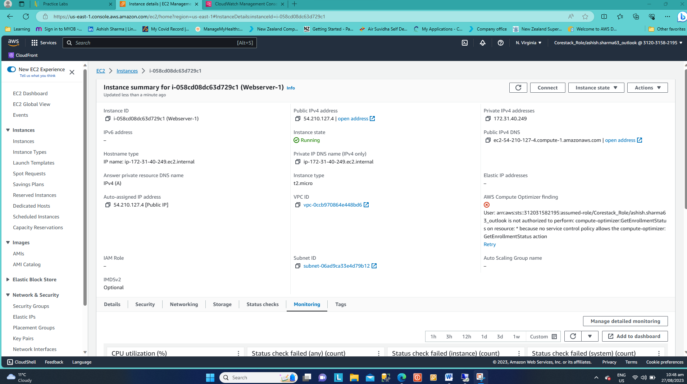

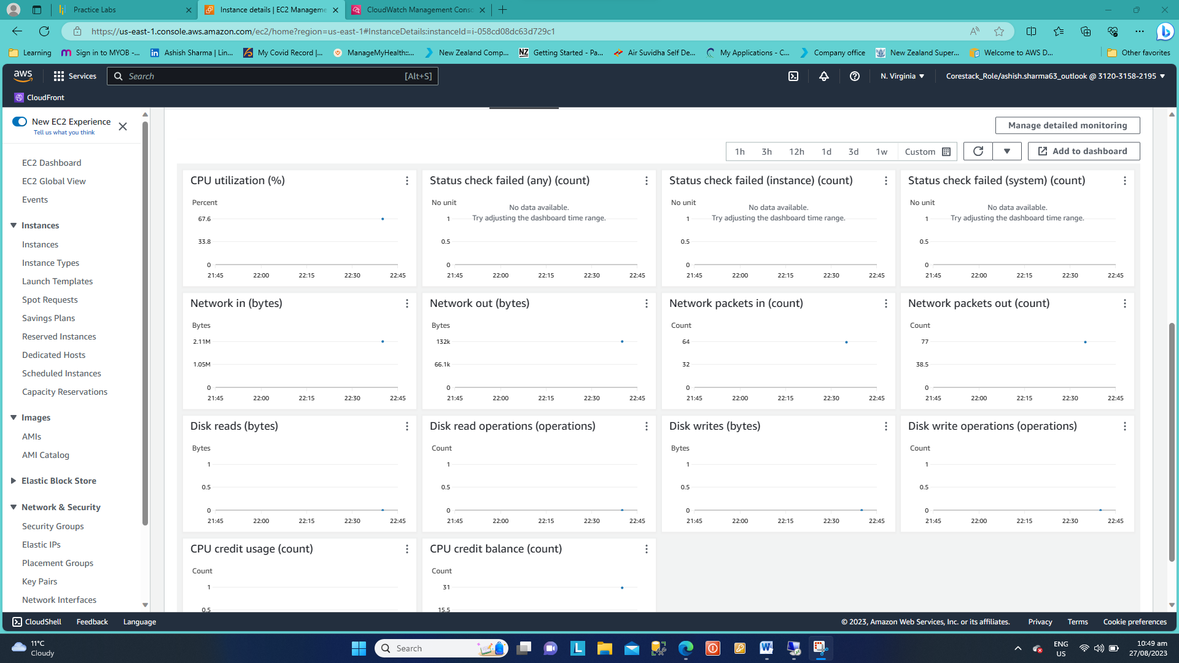

1. Create and configure a CloudWatch alarm that sends an email notification to HCMonitor@HeavenClassics.com if the CPU utilization goes below the threshold of 3%, consecutively three times for five minutes

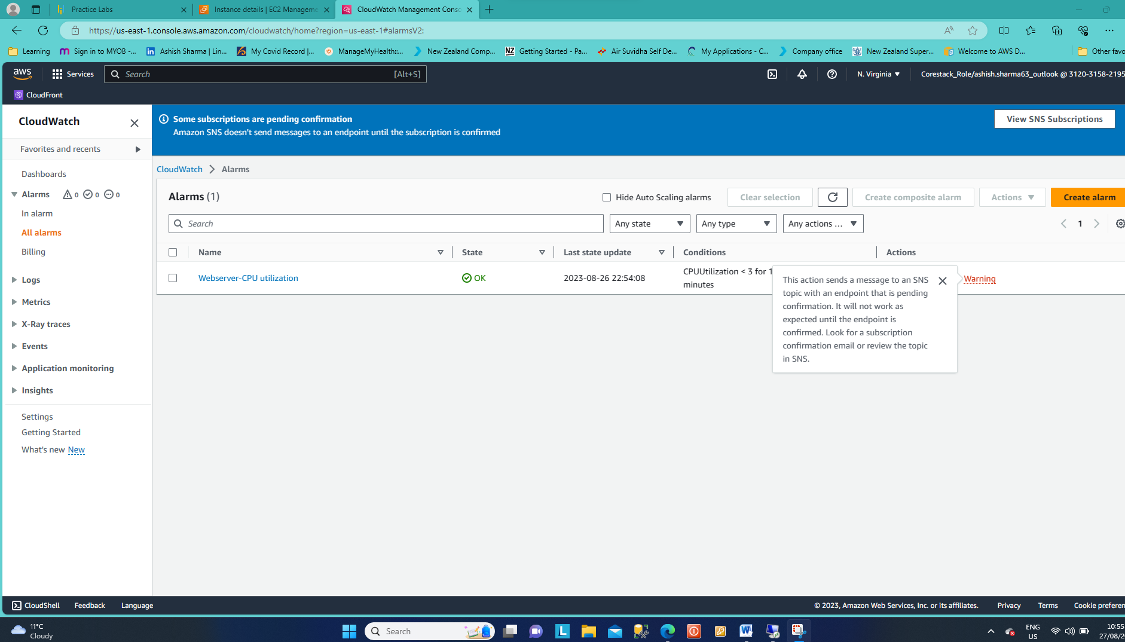

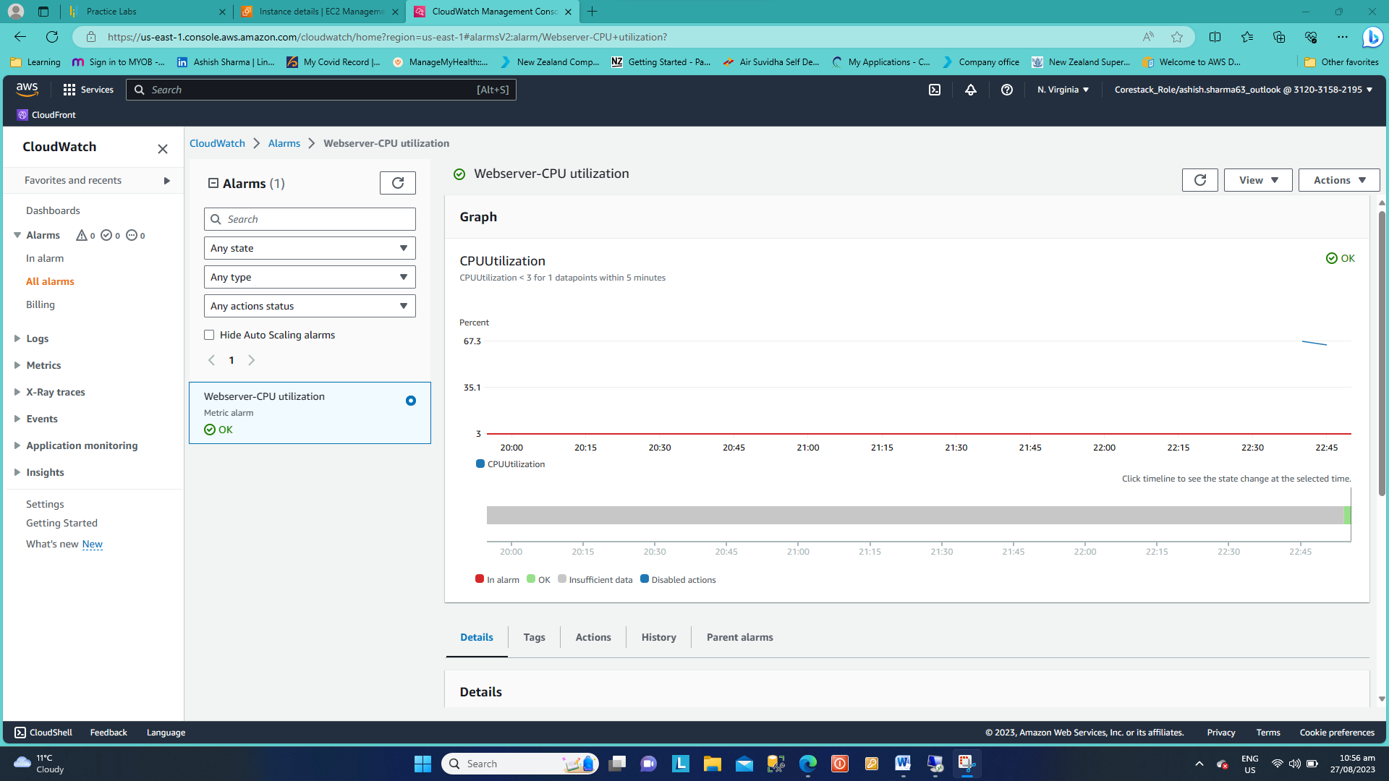

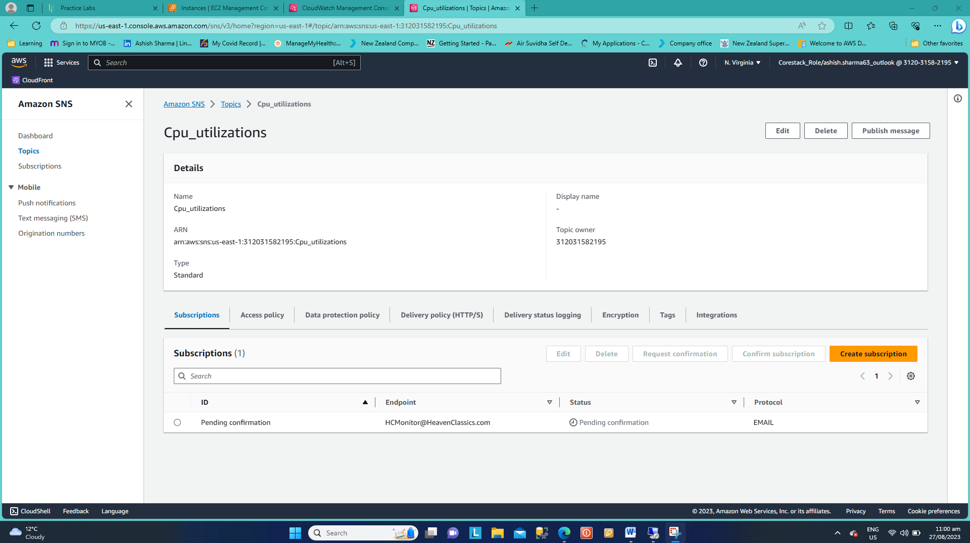

1. Create an IAM group named Administrator Group and attach the full administrator access policy to the group

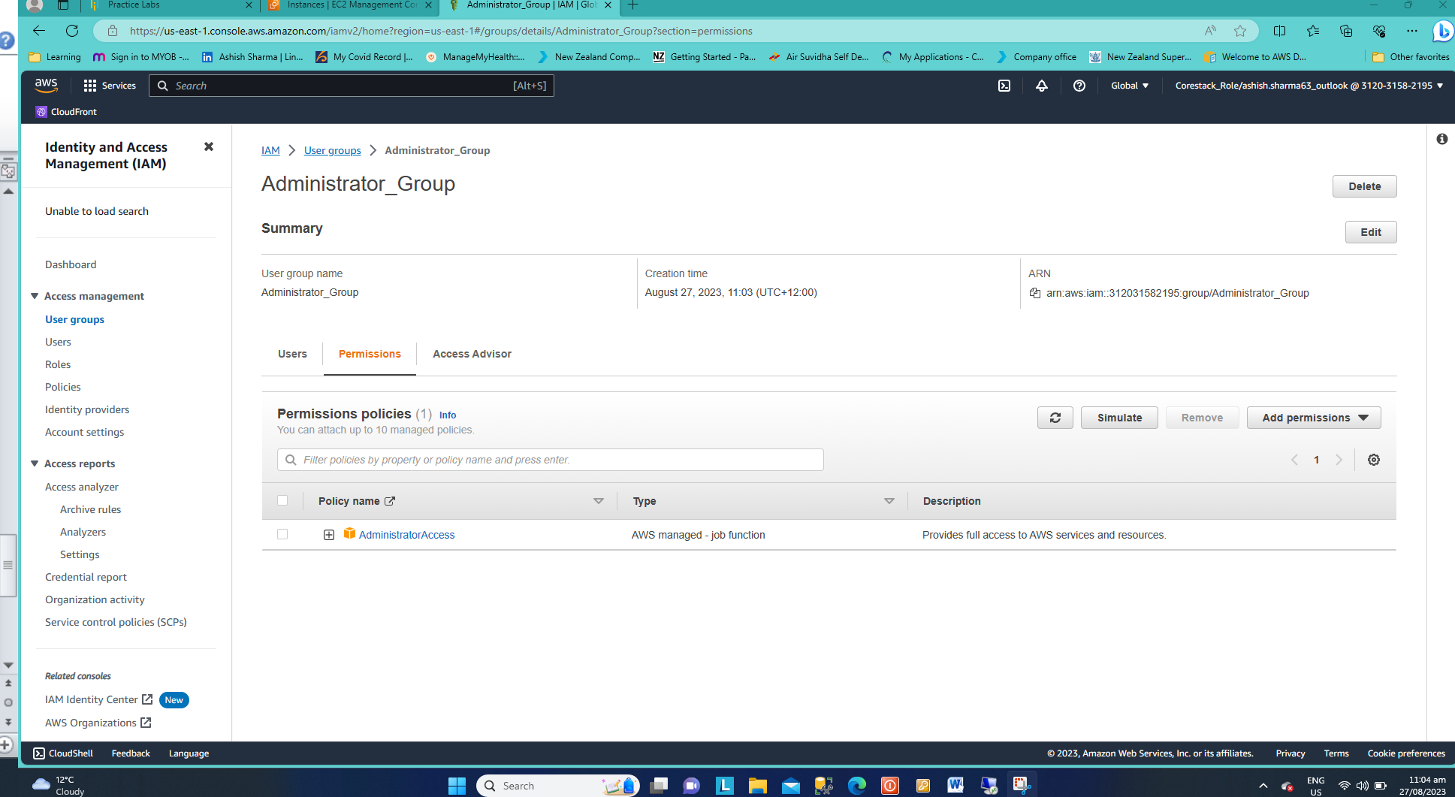

1. Create a user for an employee of the company who requires administrator access to the company's AWS account, and then add the user to the Administrator Group.

